SEMESTER TWO
Papers written by
Australian Maths Software

YEAR 11

MATHEMATICS SPECIALIST
Units 1 & 2
2016
REVISION THREE

Section One
(Calculator–free)

Name: __________________________________

Teacher: ________________________________

TIME ALLOWED FOR THIS SECTION

Reading time before commencing work: 5 minutes
Working time for section: 50 minutes

MATERIAL REQUIRED / RECOMMENDED FOR THIS SECTION

To be provided by the candidate
Standard items: pens, pencils, pencil sharpener, highlighter, eraser, ruler.

IMPORTANT NOTE TO CANDIDATES
No other items may be taken into the examination room. It is your responsibility to ensure that you do not have any unauthorised notes or other items of a non–personal nature in the examination room. If you have any unauthorised material with you, hand it to the supervisor before reading any further.

To be provided by the supervisor
Question/answer booklet for Section One.
A formula sheet which may also be used for Section Two.
Structure of this examination

 | Number of questions available | Number of questions to be answered | Working time (minutes) | Marks available | Percentage of exam
Section One  Calculator—free | 7 | 7 | 50 | 52 | 35
Section Two  Calculator—assumed | 11 | 11 | 100 | 98 | 65
Total marks |  |  |  | 150

Instructions to candidates

1. The rules for the conduct of this examination are detailed in the Information Handbook.
Sitting this examination implies that you agree to abide by these rules.

2. Write your answer in the Question/Answer booklet.

3. You must be careful to confine your responses to the specific questions asked and to
follow any instructions that are specific to a particular question.

4. Spare pages are provided at the end of this booklet. If you need to use them, indicate
in the original answer space where the answer is continued i.e. give the page number.

5. Show all your working clearly. Your working should be in sufficient detail to allow your
answers to be checked readily and for marks to be awarded for reasoning. Incorrect
answers given without supporting reasoning cannot be allocated any marks. For any
question or part question worth more than two marks, valid working or justification is
required to receive full marks. If you repeat an answer to any question, ensure that you
cancel the answer you do not wish to have marked.

6. It is recommended that you do not use pencil, except in diagrams.

7. The Formula Sheet is not to be handed in with your Question/Answer booklet.

Section One: Calculator–free 52 marks

This section has seven (7) questions. Attempt all questions.
Working time: 50 minutes

Question 1 (8 marks)

(a) Consider the complex numbers graphed on the set of axes below.
Express u and v in terms of z (4)

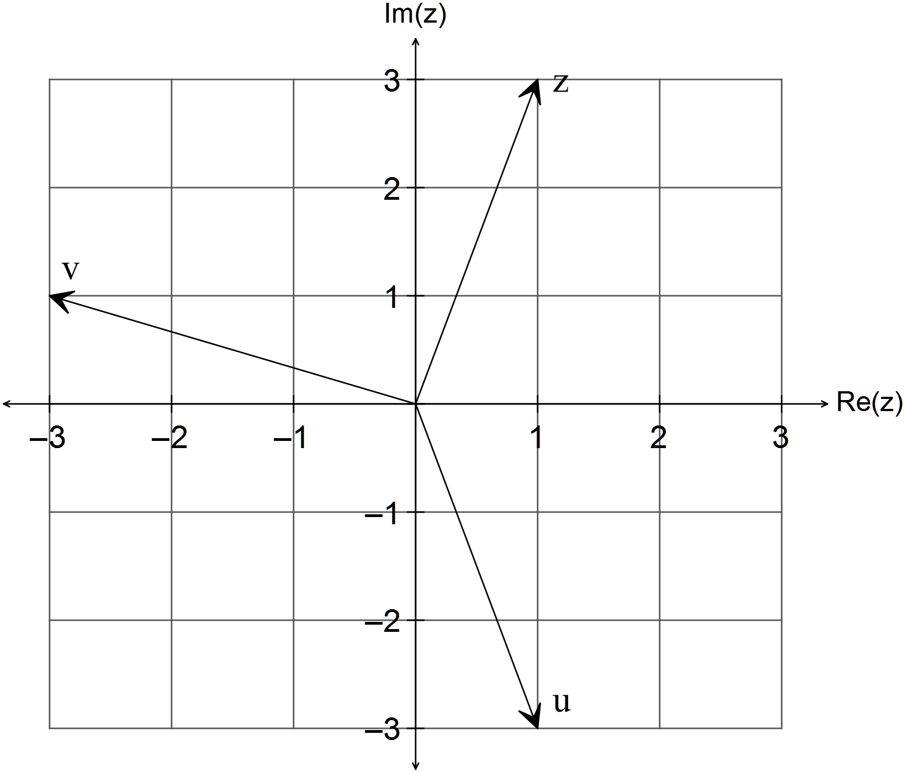

Consider the set of complex numbers 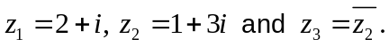

(b) Find
(i) 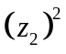 (2)

(ii) 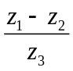 (2)

Question 2 (9 marks)

(a) Consider the following vectors 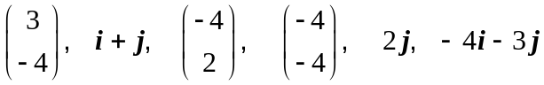.

(i) List two vectors that are parallel. (1)

(ii) List two vectors that are perpendicular. (1)

(b) Find the projection of the vector 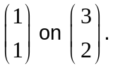 (3)

(c) Findgiven 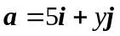and 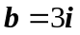 if it is known that the angle between the two
vectors is 60⁰. (4)

Question 3 (7 marks)

Given 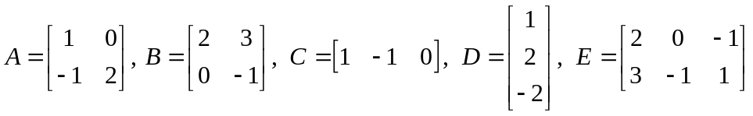 determine each of the following or else explain why it cannot be determined.

(a) 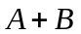 (1)

(b) 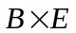 (2)

(c) 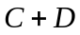 (2)

(d) 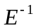 (2)

Question 4 (8 marks)

(a) Simplify the following 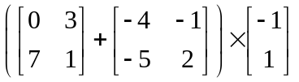 (2)

(b) Solve for 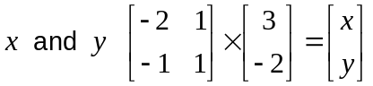 (2)

(c) Calculate if 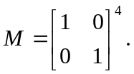 (1)

(d) Determine whether or not 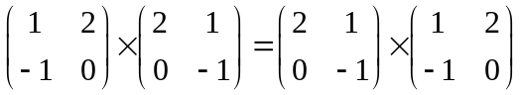 (3)

Question 5 (8 marks)

(a) (i) Use the unit circle to explain why 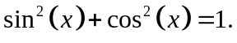 (1)

(ii) Use the identity 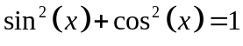 to establish and identity for 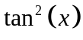
In terms of 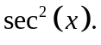 (2)

(b) (i) Show that 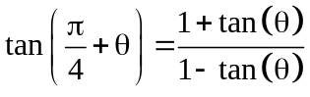. (2)

(ii) Show that 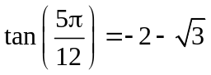.
HINT: 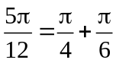 (3)

Question 6 (4 marks)
(a) Sketch the function 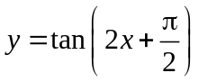 on the domain 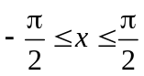. (2)
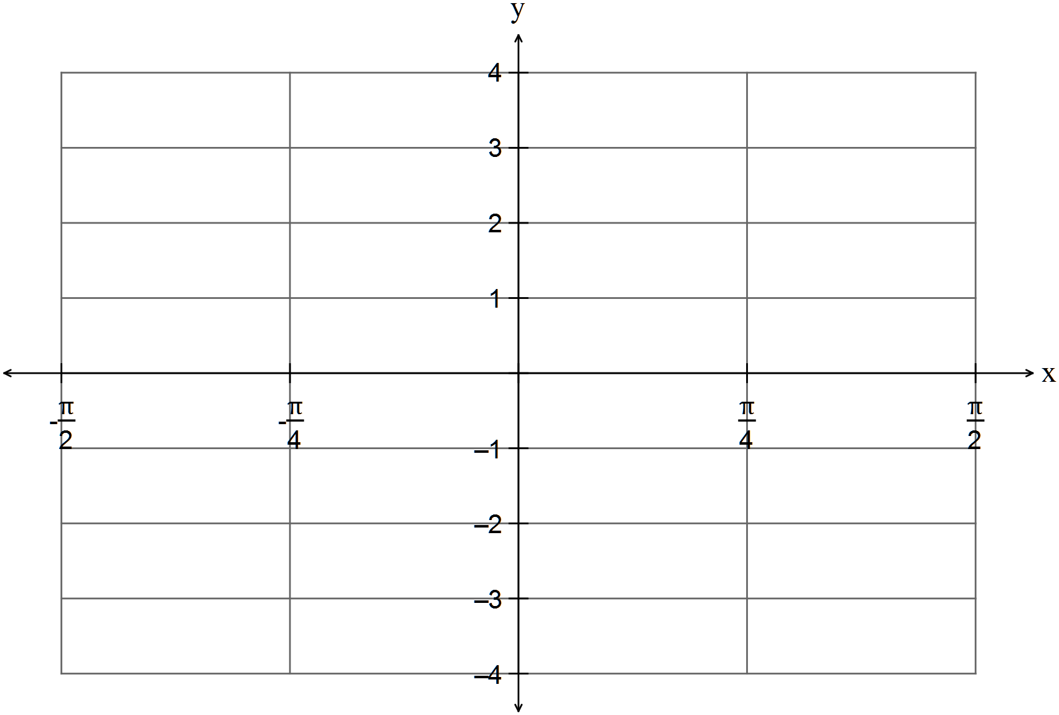

(b) Sketch the function 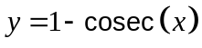on the domain 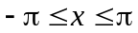 (2)
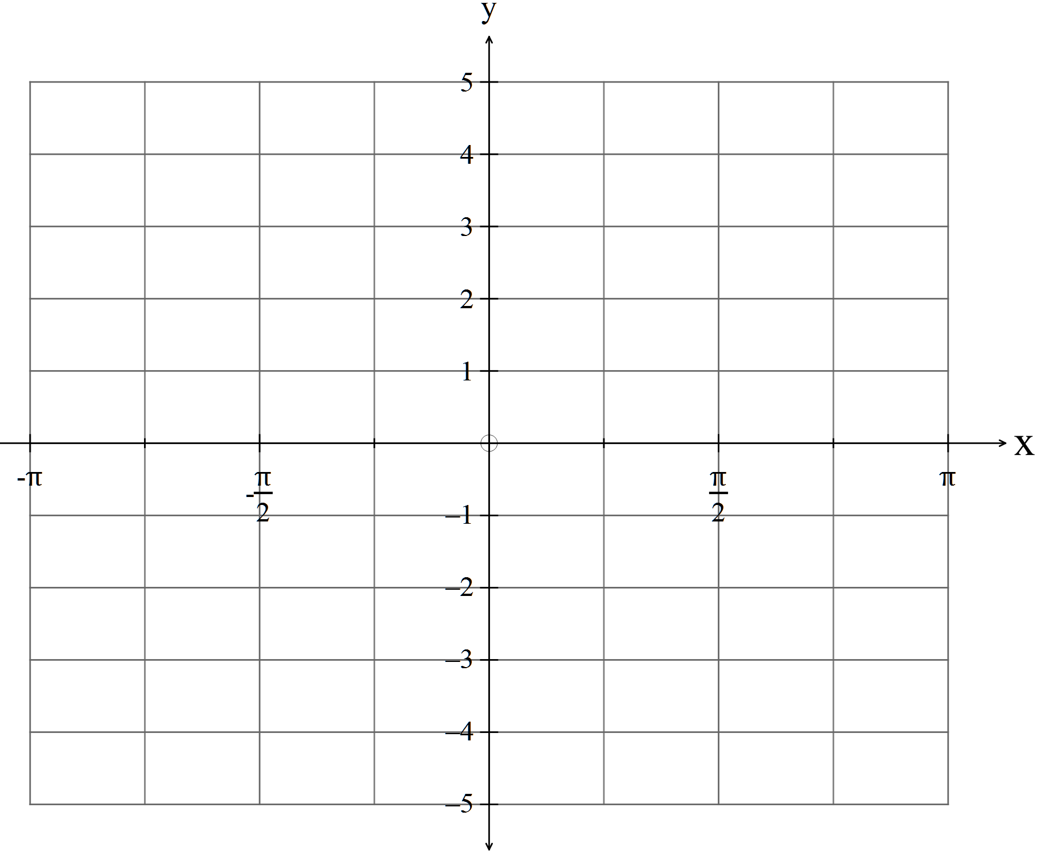
Question 7 (8 marks)

(a) Provide a counter example to show that the following statement is false. (1)

“If a quadrilateral has four right angles and equal diagonals, then it is a square.”

(b) Prove that “The opposite angles of a cyclic quadrilateral are supplementary.” (3)

(c) Prove the following using vectors
“The three medians of a triangle are concurrent at the point of trisection.” (4)

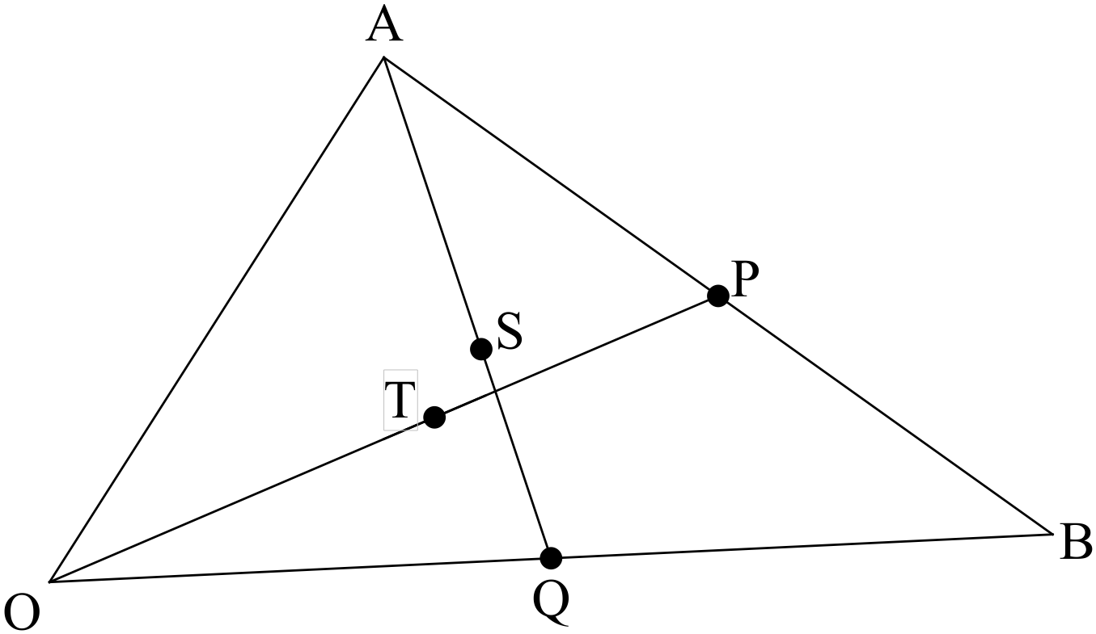

Let ABC be the triangle. P and Q are the midpoints of sides AB and AB respectively.
Let T and S be the points of trisection of OP and AQ respectively.

END OF SECTION ONE

